MEMBERS’ OUTINGS August 2023 - January 2024

To book ring
020 8948 1090
HAM AND PETERSHAM SOS
The Woodville Centre, Woodville Road, Ham, TW10 7QW
Payments must be made at time of booking each trip
DATE AND TIME | DESTINATION
Tues 1st AUG  10am | Petersham Nurseries monthly coffee morning (cake and tea/coffee provided) aims to get more members of the community accessing the lovely nursery. Transport can be arranged. Booking is essential.

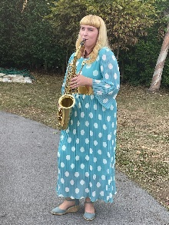
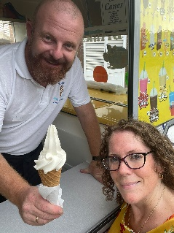
Tuesday 8th August

Ham & Petersham SOS Summer Garden Party

4:30pm-6pm at The Woodville Centre

Transport can be arranged for those who need it.

Come and enjoy the sunshine in the sensory garden.

FRIDAY 25th AUGUST  Cost £8 | FISH AND CHIPS FRIDAY at HAM LIBRARY  Traditional fish & chips with friends. On the 4th Friday of the month, food, friends, a warm and friendly atmosphere and the opportunity to eat a hot meal with others. Booking & pre payment is ESSENTIAL
FRIDAY 1st SEPT  Cost £3 per person | Transport to Tea & Treats, Swinnerton Hall Kingston.  1st Friday of the Month  The minibus will pick you up from home and take you to Tea & Treats for 11am. Pick ups are from 10:30am. The minibus will be ready to drop you home at 2pm. Booking is essential!
TUES 5th SEPT  10am | Petersham Nurseries Coffee Morning. Booking is essential.
TUES 12th SEPT  Cost £10  Journey time: 90 minutes | 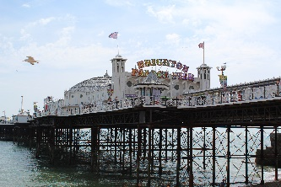  TRIP TO THE COAST  We will be leaving Ham Library at 9:30am  We are off to Brighton again this year.  With plenty to see and do, or simply enjoy fish and chips on the pier, Brighton has it all. The minibus will drop you at the sea front, allowing you to enjoy your day, and then pick you up from the same place for the journey home.
FRIDAY 22nd SEPT  Cost £8 | FISH AND CHIPS FRIDAY at HAM LIBRARY  Traditional fish & chips with friends on the 4th Friday of the month. Booking & pre payment is ESSENTIAL
TUES 3rd OCT  10am | Petersham Nurseries Coffee Morning. Booking is essential.
FRIDAY 6th OCT  Cost £3 | Transport to Tea & Treats, Swinnerton Hall Kingston  Booking is essential!
TUES 10th OCT  Cost £10  Journey time: 60 minutes | 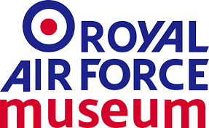  RAF MUSEUM HENDON  We will be leaving Ham Library at 10am  We are off to The museum to see all things RAF from the early first aircraft, to examples from WW1 and Spitfires, Lancaster bombers and other aircraft from WW2 to more up to date aircraft flown by the Royal Air Force.  Lunch will be included in the cost of this trip thanks to some funds from the London Borough of Richmond upon Thames.
FRIDAY 27th OCT  Cost £8 | FISH AND CHIPS FRIDAY at HAM LIBRARY  Traditional fish & chips with friends on the 4th Friday of the month. Booking & pre payment is ESSENTIAL
FRIDAY 3rd NOV  Cost £3 | Transport to Tea & Treats, Swinnerton Hall Kingston  Booking is essential!
TUES 7th NOV  10am | Petersham Nurseries Coffee Morning. Booking is essential.
TUES 9th NOV  Cost £18  Journey time: 40 minutes | CHRISTMAS SHOPPING IN STAINES UPON THAMES  We will be leaving Ham Library at 10am  We will once again be heading to Staines town center for a spot of Christmas shopping and then a group lunch at the Harvester.  Lunch is included in the cost of this trip.
FRIDAY 24th NOV  Cost £8 | FISH AND CHIPS FRIDAY at HAM LIBRARY  Traditional fish & chips with friends on the 4th Friday of the month. Booking & pre payment is ESSENTIAL
FRIDAY 1st DEC  Cost £3 | Transport to Tea & Treats, Swinnerton Hall Kingston  Booking is essential!
TUES 5th Dec  10am | Petersham Nurseries Coffee Morning. Booking is essential.

CHRISTMAS LUNCH

Details to be comfirmed nearer the time
TUES 9th JAN 2024 | CARVERY LUNCH  Details to be confirmed nearer the time
FRIDAY 26th JAN  Cost £8 | FISH AND CHIPS FRIDAY at HAM LIBRARY  Traditional fish & chips with friends on the 4th Friday of the month. Booking & pre payment is ESSENTIAL
FRIDAY 2nd FEB  Cost £3 | Transport to Tea & Treats, Swinnerton Hall Kingston  Booking is essential!

Please make all cheques payable to: Ham and Petersham SOS

Cancellations: We will only refund trip money if cancellations are made 7 days before the trip. We often run waiting lists and this would allow us to offer your place to another SOS member and we also have to pre-book entrance tickets. We will consider requests for a refund on an individual basis if short-notice cancellations occur.

