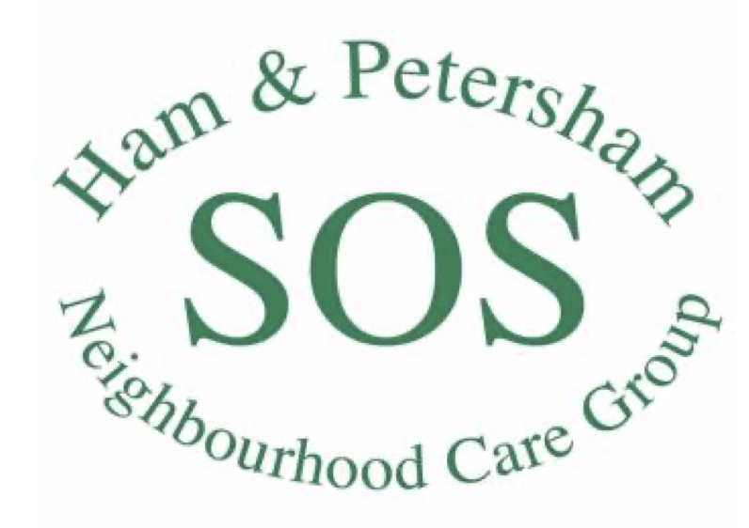

Health & Safety Policy
GENERAL STATEMENT OF HEALTH & SAFETY POLICY
- Ham & Petersham SOS, hereafter called HAPSOS, recognises and accepts its responsibility as an employer for providing a safe and healthy workplace and working environment for all its employees and those who may be affected by its operations, such as our volunteers and our clients.

- HAPSOS will take the necessary action to meet this responsibility by complying with all statutory requirements and approved codes of practice and by developing its own policies and codes of practice where legal requirements or standards do not exist or are met and can be surpassed. Our health & safety policy is in place to:
  - Maintain safe and healthy working conditions;
  - Manage health and safety risks in our workplace;
  - Help prevent accidents and cases of work-related ill health;
  - Provide clear instructions and information on procedures, roles and responsibilities with regard to health and safety.

- HAPSOS will review and revise this policy regularly, consulting employees on matters affecting health & safety in the process.

Signed (Chair of the Board of Trustees):

Date:

RESPONSIBILITIES FOR HEALTH & SAFETY

- The Board of Trustees will have responsibility for ensuring the Health & Safety policy is appropriate and up to date with the relevant legislation.

- The Organiser is responsible for ensuring this policy is put into practice and regularly reporting back to the Board of Trustees on health & safety matters. The Organiser is also responsible for all RIDDOR reporting where relevant.

- All employees should:
  - Cooperate with supervisors/managers on health & safety matters;
  - Take reasonable care of their own health and safety and that of others;
  - Familiarise themselves with all applicable safety rules and follow instructions for the safe use of equipment; and
  - Report all health & safety concerns to the Organiser.

ARRANGEMENTS FOR HEALTH & SAFETY
- RISK ASSESSMENTS:
- The Organiser will ensure that relevant risk assessments are conducted at all HAPSOS premises of work.
- Where relevant, the risk assessment should consider, but not limited to the following:
  - Fire risks
  - Emergency evacuation procedures
  - First Aid provision
  - Hazards
  - Electrical and mechanical equipment
  - Heavy loads
- A risk assessment template can be found in the HAPSOS online filing system.
- Each risk assessment will be reviewed regularly and in particular, when working habits or conditions change.

- WORKING AWAY FROM HAPSOS PREMISES:
  - Due to the nature of the work that takes place within the charity, it may be necessary to work away from H&PSOS premises. For example, on outings, shopping bus trips, client home visits and transporting clients.
  - It may not be feasible to conduct a risk assessment in advance, however, risks to health and safety should be considered by the responsible staff member and any relevant procedures followed.
  - The Organiser will ensure that appropriate procedures are in place to help mitigate health and safety risks whilst working away from HAPSOS premises.
  - These procedures will be documented in the HAPSOS online filing system.

- EMERGENCIES – FIRE:
  - FIRE – things to do now:
    - Find out where the nearest fire alarm is to your place of work and what it sounds like.
    - Find out what your escape route would be in the event of fire there are also alternative routes if the main route is blocked by fire.
  - If you hear the Fire Alarm:
    - If the alarm is sounded, IT IS A FIRE ALARM AND YOU MUST EVACUATE THE BUILDING AS DIRECTED.
    - Alarms must always be acted upon unless they are maintenance tests, which are normally notified in advance.
    - If it is outside normal office hours, telephone the Fire Brigade (see (c) below), leave the building, and telephone the Organiser.
    - You should walk speedily but do not run.
    - You should go to your assembly point outside H&PSOS premises. You should also be familiar with the assembly point used at any other premises you may be working at.
    - If you can close doors and windows without putting yourself at risk, then this will help prevent the spread of fire and smoke.
    - Do not go back into the building until you are told it is safe to do so by the Fire Officer in charge.
  - If You Discover a Fire:
    - Immediately operate the nearest fire alarm then call the Fire Brigade by dialling 999. Ensure the operator repeats the correct address.
    - Assist any person within your workplace, or member of the public, who has a mobility, hearing or sight disability. Only use Fire and Rescue Service approved evacuation chairs to help those persons with mobility problems down stairs, etc.
    - If someone's clothing is on fire lay them down with the burning side up as soon as possible to prevent flames and smoke reaching their head. Use a blanket, a heavy top coat or rug and wrap it around the person to extinguish flames.

- ACCIDENTS, FIRST AID & ACCIDENT REPORTING:
  - First Aid facilities will be available at all HAPSOS premises. Familiarise yourself with their locations now.
  - If working at other venues away from HAPSOS premises, familiarise yourself with the location of the First Aid facilities.
  - All accidents and injuries at work, however minor, should be reported to the Organiser and recorded in the Accident Book which is kept in the HAPSOS office.
  - The Organiser is responsible for ensuring First Aid kits are checked at least annually and ensuring used stock is replenished.

- INDUCTION AND TRAINING:
  - The Organiser is responsible for ensuring that all employees and volunteers who operate in HAPSOS premises or at other venues have an appropriate health & safety induction.
  - Where relevant, all employees must receive appropriate training to be able to carry out their work.

- NORMAL WORK SITUATIONS:
  - DSE: The can be health risks associated with working with display screen equipment (DSE), such as PCs, laptops, tablets and smartphones and it is important that employees work safely with DSE. To reduce risks of health related issues it is important that:
    - Workers take regular breaks or do something different.
    - Work stations are set up appropriately to help reduce risks of pain in necks, shoulders, backs, arms, wrists and hands as well as fatigue and eye strain.
For further guidance, please see https://www.hse.gov.uk/msd/dse/
  - Hazards: Many hazards exist in the workplace and these should never be ignored. Lesser dangers or less apparent dangers are more likely to be overlooked and employees may become careless or unaware of the risk involved. Complacency and bad habits are usually at the root of most accidents.
    - Everyone must accept a degree of responsibility for their own personal safety. failure to observe rules can be regarded as contributory negligence. it is most important that all rules and accepted safety practices are understood.
    - You must use equipment in accordance with any instructions given to you. Any equipment fault or damage must immediately be reported to the Organiser. Do not attempt to repair equipment unless trained to do so.

- RIDDOR REPORTING:
  - The Organiser will be responsible for maintaining the Accident Book and reporting under RIDDOR
  - What is RIDDOR? RIDDOR is the law that requires employers, and other people in control of work premises, to report and keep records of: work-related accidents which cause death; work-related accidents which cause certain serious injuries (reportable injuries); diagnosed cases of certain industrial diseases; and certain ‘dangerous occurrences’ (incidents with the potential to cause harm).
  - Not all accidents need to be reported. A RIDDOR report is required only when:
    - the accident is work related; and
    - it results in an injury of a type which is reportable.
RIDDOR reporting requirements can be found here: https://www.hse.gov.uk/riddor/.
  - Types of reportable injury:
    - The death of any person - All deaths to workers and non-workers, with the exception of suicides, must be reported if they arise from a work-related accident, including an act of physical violence to a worker.
    - Specified injuries to workers: Specified injuries are (regulation 4):
      - fractures, other than to fingers, thumbs and toes
      - amputations
      - any injury likely to lead to permanent loss of sight or reduction in sight
      - any crush injury to the head or torso causing damage to the brain or internal organs
      - serious burns (including scalding) which: covers more than 10% of the body or causes significant damage to the eyes, respiratory system or other vital organs
      - any scalping requiring hospital treatment
      - any loss of consciousness caused by head injury or asphyxia
      - any other injury arising from working in an enclosed space which: leads to hypothermia or heat-induced illness or requires resuscitation or admittance to hospital for more than 24 hours
  - Injuries to non-workers:
    - Work-related accidents involving members of the public or people who are not at work must be reported if a person is injured, and is taken from the scene of the accident to hospital for treatment to that injury. There is no requirement to establish what hospital treatment was actually provided, and no need to report incidents where people are taken to hospital purely as a precaution when no injury is apparent.
    - If the accident occurred at a hospital, the report only needs to be made if the injury is a ‘specified injury’ (see above).
  - Reportable dangerous occurrences:
    - Dangerous occurrences are certain, specified ‘near-miss’ events (incidents with the potential to cause harm.) Not all such events require reporting. There are 27 categories of dangerous occurrences that are relevant to most workplaces. For example: Electrical incidents causing explosion or fire results in the stoppage of the plant involved for more than 24 hours or causes a significant risk of death. More information can be found here https://www.hse.gov.uk/riddor/

