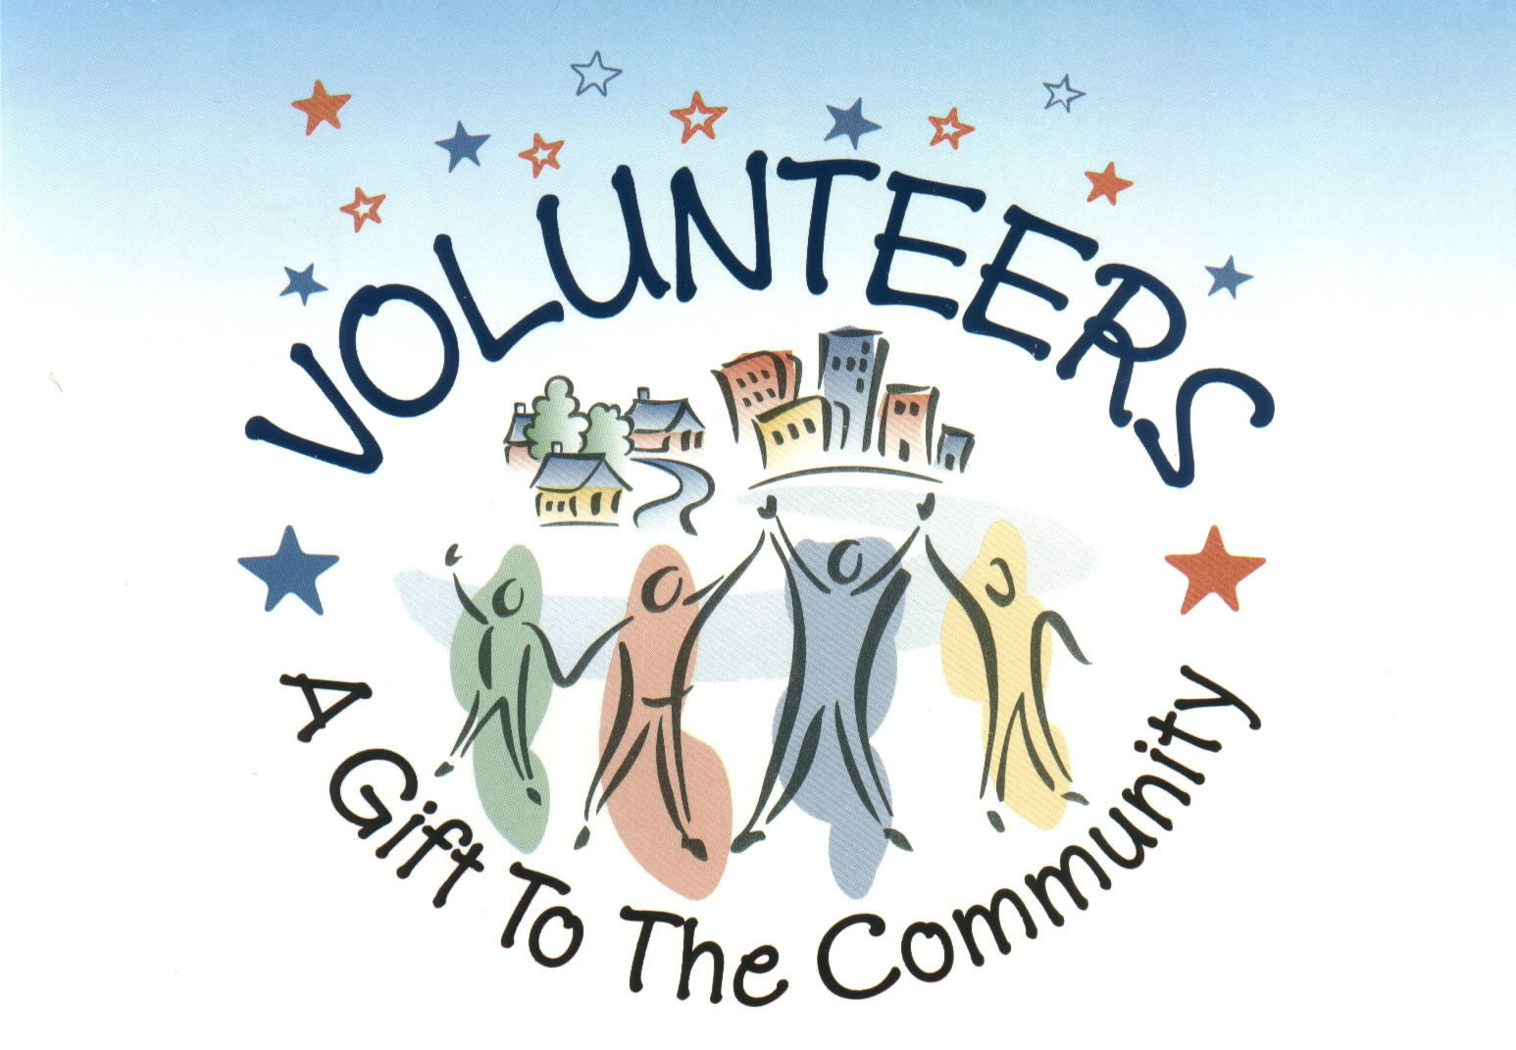

GENERAL INFORMATION FOR VOLUNTEERS

JOBS AND CONTACTING CLIENTS

- If you have any queries about a job you can get advice from the volunteer on telephone duty between 10:00 and 12:00 Monday to Friday on 020 8948 1090.
- It is always better to ring the telephone volunteer regarding jobs since I am not always in the office and may miss a message left on my phone or email.
- To protect your privacy we use first names only.
- It is important not to give clients your phone number or address.
- Jobs should always be referred through the office.
- If you have a BT landline, dial 141 before you phone a client’s telephone number so that they are unable to trace the call.
- We ask that you call clients the night before a job to introduce yourself and confirm job details.
- It is essential that we preserve confidentiality in relation to client’s affairs and personal details.

DRIVING GUIDLINES
- Your name will be added to our driver’s list with details of your availability.
- Our volunteers will contact you with details of transport that is required.
- All passengers should wear front and rear seat belts unless there are medical or disability grounds not to.
- Drivers should not drink alcohol for at least 12 hours before a journey.
- Luggage or shopping should be put in the boot or kept securely to prevent injury if the vehicle suddenly stops.
- Pets can be carried with clients at the discretion of the driver as long as the animal does not affect the safe running of the vehicle.
- Never exceed the seating capacity of a vehicle as stated by the manufacturer.

PARKING, BLUE BADGES AND PETROL CLAIMS
- All mileage is currently reimbursed at 40p per mile by Richmond Council.
- Mileage claim forms are available from the office or from the website.
- Claims are paid to you by cheque or by telephone banking.
- If you do not intend to claim please sign the form attached to give us permission to claim as a donation to our organisation.
- The client is responsible for paying any parking charges or congestion charges that you may incur.
- A number of clients have blue badges that enable you to park in disabled bays and in some cases the parking fee is waivered.
- Please make sure badges are clearly displayed in your windscreen.
- If you take anyone out for tea/coffee or a meal they should pay for themselves.

DONATIONS
- Clients are aware that we suggest a voluntary £2.00 donation for each job.
- Sometimes clients will send a cheque to the office, other times they will give the money directly to volunteers.
- Please bring donations to the office between 10 and 12, or put it in an envelope addressed to us with the donor’s name and post it through the letterbox at the front of our building.
- No one is excluded from our services due to inability to make a donation.
- If you are comfortable reminding a client that donations are useful a tactful way might be:

“Would you like to make a donation today or will you contact the office directly?”

HOSPITAL APPOINTMENTS
- If you are taking a client to hospital for a possible lengthy appointment leave your phone number in an envelope with the receptionist, who can ring you when the client is ready to be collected.
- We have parking permits for Kingston Hospital in our office but since they are scratch cards and they are difficult to get hold of we use them sparingly. For example, if you are just dropping someone off for a hospital appointment there would be no need to take the card.

REGULAR JOBS, LIST SHOPPING AND BEFRIENDING
- If you are happy to undertake a job on a regular basis please fill in our regular job form which can be collected from the office or downloaded from the website.
- If you are list shopping for a client it is not always necessary to visit them in person to collect the list. You may ring the day before and get the list over the telephone if you prefer.
- The most common regular jobs are list shopping and befriending.
- Befriending arrangements and in some instances list shops are the only services that might be made outside of the office between the volunteer and client.
- Befriending training is offered two or three times each year, so please let me know if you are interested in helping with this service.

ACCIDENTS AND ILLNESS
- It is important to let the Office know as soon as possible about any accident that may have occurred to a client, yourself or your car whilst you were on SOS duties.
- If a client falls ill during a journey the driver should seek appropriate medical help and also inform Ham & Petersham SOS
- If the office is closed and you are concerned about a client please ring the emergency services.
- It would be useful to report any other concerns that you may have about a client particularly about their mobility which may help another driver in future.

WHEELCHAIRS AND FRAMES
- The office will inform you if a job involves a client in a wheelchair or frame.
- Clients who use wheelchairs may need some assistance getting in and out of a car.
- Wheelchairs and frames need to be folded and transported in the car boot.
- If you do not feel able to do this for any reason please let us know.

Please feel easy about refusing a request. Your family and home commitments come first. We want you to enjoy the work and not to find it stressful. If you feel you are asked to do too little or too much, please let us know. If you have any worries or concerns ring me on my direct line 020 7195 0281

INSURANCE INFORMATION FOR VOLUNTEERS

CAR INSURANCE

- Prior to starting voluntary driving we will need to see your driving licence and insurance documents

- If you have an accident whilst driving for Ham and Petersham SOS you will need to claim through your own private insurance.

- It will be necessary for you to inform your car insurance company in advance that you will be driving in a voluntary capacity for no monetary gain. This should not affect your insurance in any way.

- If your insurance company raises any problem please inform the office.

- We suggest you send a letter to your insurance company with the following paragraph:

'From time to time I may be using my car to carry passengers on behalf of the Ham and Petersham SOS Neighbourhood Care Group. Under certain circumstances I may receive a mileage allowance for so doing to cover expenses but not to include any element of profit. I should be grateful if you would confirm the continuation of cover in these circumstances'

PUBLIC LIABILITY INSURANCE

- The Organisation is insured against liability to the public in connection with any specified activity organised by the Ham and Petersham SOS.

- Committee members and volunteer helpers are also covered against personal accident whilst similarly engaged in any specified activity organised by the Ham and Petersham SOS.

